Physics 30 Lesson 3A Energy, Work and Power

# Energy and its forms

The idea of Energy is the most fundamental principle in all of science. Everything in the universe is a manifestation or form of Energy. Energy is the fundamental or basic "stuff" of the universe. All physical processes can be understood as the transformation of one type or kind of energy into another.

**Chemical** energy exists within the bonds that hold atoms together

**Radiant** various forms of light energy

radio / TV / microwaves / infrared (heat) / visible light / ultra violet

**Electromagnetic**

electric potential energy (battery)

electric current

magnetic potential energy

**Atomic** binding energy within the nucleus

strong force holds protons and neutrons together

weak force destabilizing force (radioactive decay)

**Mechanical**

*kinetic energy* energy due to the motion of an object (EK = ½ m v2)

*gravitational potential energy* energy due in a gravitational field (Ep = m g h)

*elastic potential energy* energy stored in a spring (Ep = ½ k x2)

Physics 30 is really a study of different forms or types of energy. In future lessons we will be working with Radiant, Electromagnetic and Atomic energy, but for now we are going to limit our discussion of energy to Mechanical energy and the transformations between various forms of Mechanical energy.

# Mechanical Energy

There are two basic kinds of mechanical energy:

Kinetic Energy energy due to motion

Potential Energy energy due to position (stored energy)

For those who are interested, the ideas of mechanical energy and work were developed by people like Thomas Newcommen (inventor of the steam engine), James Watt (refined steam engine design), James Prescott Joule (a beer brewer who demonstrated the equivalence of mechanical and heat energy), and many others during the Industrial and Scientific Revolutions. These people were interested in creating machines to move objects (kinetic) and lift objects (potential) as efficiently as possible.

Business men and factory owners were interested in making the greatest profit possible. This meant they had to keep their input costs (labor, fuel, machinery, housing, etc.) as low as possible. The major sources of raw energy in England and Europe was, and to a large degree still is, coal. Coal costs money to mine, ship and burn. Therefore, if a factory owner could use the energy in the coal (chemical potential) to produce kinetic and potential energy without losing the energy to heat energy, his profits would be good. People wanted to find ways of producing mechanical energy, doing work, as efficiently as possible. The people who work with the principles of mechanical energy are called mechanical engineers.

# The Laws of Energy

*First Law of Energy*

The total energy is neither increased nor decreased by any process. Energy can be transformed from one form to another, and transferred from one object(s) to another object(s), but the total amount of energy remains constant.

*Second Law of Energy*

Heat flows naturally from a hot object to a cold object; heat will not flow spontaneously from a cold object to a hot object. A consequence of this one-way flow is that no device is possible which can completely transform a given amount of heat energy into work. Some mechanical energy is always “lost” as heat.

# Work

The word “work” has many different meanings to different people, but it generally means to expend effort in a certain endeavour. In physics, the concept of work has a definite meaning which is quite different from its common usage. The principle of work can be summed up in two statements:

1. In order to change the energy of an object *work* must be done on the object – i.e. its mechanical energy (kinetic and/or potential) will change.

W =  E

2. The work done on an object by a constant force F is given by:

❑

**F**

**d**

W = F cos . d

where d is the displacement and  is the angle between the force and the displacement. Work is a scalar quantity with units (N•m) or (J) which are equivalent units of energy.

Note:

When  = 0o (i.e. the force is parallel to the displacement) W = F d

When  = 90o, W = 0. No work is done.

A workman exerts a horizontal force of 30 N to push a 12 kg table 4.0 m across a level floor at constant speed. Calculate the work done.

F = 30 N W = F d = 30 N (4.0 m)

d = 4.0 m

W = ? W = **120 N•m**



Find the work done in pulling a luggage carrier by a 45.0 N force at an angle of 50o for a distance of 75.0 m.

F = 45.0 N W = F d cos  = 45.0 N (75.0 m) cos 50o

d = 75.0 m

❑ = 50o W = **2.17 x 103 N•m**

W = ?

# Net Work

Remember, work is defined as a change in mechanical energy (kinetic and/or potential).

W = E

Work against a frictional force will be lost as heat energy. Thus, it is the ***net force*** that causes a change in kinetic and/or potential energy. Work can be either positive or negative depending on whether the force points in the same or opposite direction as the displacement.

A weight lifter is bench-pressing a barbell whose mass is 110 kg. He raises the barbell a distance of 0.65 m above his chest and then lowers the barbell the same distance. The weight is raised and lowered at a constant velocity. Determine the work done on the barbell by the lifter when (a) the barbell is lifted and (b) when it is lowered. (c) What was the net work done?

m = 110 kg since the barbell is moved at constant speed, Fnet = 0

d = 0.65 m ∴ F = Fg = mg

W = ?

(a) W = F d = mg d = 110 kg(9.81 m/s2) 0.65 m

W = **+ 7.0 x 102 N•m**

(b) W = F d = mg d = 110 kg(9.81 m/s2) (-0.65 m)

W = **- 7.0 x 102 N•m**

(c) Wnet = Wa + Wb = +7.0 x 102 N•m + (-7.0 x 102 N•m)

Wnet = **0**

40o

FA = 200 N

 m

Ff = 60 N

50 kg

A 50 kg crate is being dragged across a floor by a force of 200 N at an angle of 40o from the horizontal. The crate is dragged a distance of 5.0 m and the frictional force is 60 N.

A. What is the work done on the crate by the applied force?

WA = FA d cos  = 200 N (5.0 m) cos 40o

WA = **766 N•m**

B. What is the work done on the crate by the frictional force?

Wf = Ff d = 60 N (5.0 m)

Wf = **300 N•m**

C. What is the net work done on the crate?

Wnet = WA - Wf = 766 N m - 300 N m

Wnet = **466 N•m**

D. What form(s) of energy were produced by the net force and the applied force?

net force → kinetic energy

applied force → kinetic + heat energy

# The Work – Energy Theorem

The formal definition of the **work-energy theorem** is that work results in a change in kinetic energy

W =  Ek

However, a more general and useful definition is that work done on an object results in a change in kinetic, potential or heat energy:

W =  E

From this equation we can derive the equations for kinetic energy, gravitational potential energy, and spring potential energy.

a. *Kinetic energy* (a force (F) is applied through a distance (d))



m

F

d

**EK = ½ m v2**

b. *Gravitational potential energy* (a force (Fg) is applied through a distance (h))



m

h

**Ep = m g h**

c. *Elastic potential energy* (a spring with constant k is stretched a distance (x))

According to Hooke’s law F = kx. Therefore, the force required to stretch a spring becomes larger as a spring is stretched:

F

F = k x

x

W = area = ½ a b = ½ (kx)(x) = ½ kx2

**Ep = ½ kx2**

A 20 kg object is lifted from a table to a vertical height of 0.50 m above the table. What is the gravitational potential energy of the object with respect to the table?

m = 20 kg Ep = m g h = 20 kg (9.81 m/s2) (0.50 m)

h = 0.50 m

Ep = ? Ep = **98.1 J**

An archer draws an arrow back by exerting an average force of 90 N on the string. If the string is drawn back 80 cm, what is the elastic potential energy of the bow string?

F = 90 N Ep = W = F d = 90 N (0.80 m)

d = 0.80 m

Ep = ? Ep = **72 J**

A 50 N force stretches a spring by 0.75 m. What is the spring constant and how much energy is stored in the spring?

F = 50 N  = **66.7 N/m**

x = 0.75 m

k = ? Ep = ½ kx2 = ½ (66.7 N/m) (0.75 m)2 = **18.75 J**

Ep = ?



What is the kinetic energy of a 40 kg object that is traveling at 50 m/s?

EK = ½ m v2 = ½ (40 kg) (50 m/s)2 = **50 kJ**

# Power

The rate at which work is done, or the rate of energy consumption, is called the *power*.

 unit is a Watt ( W ) W = J / s

An alternate formula, which is not on your formula sheet, for power is:



*Example 11*

How much work can a 1.5 kW kettle do in 10 minutes?

P = 1.5 kW = 1500 W W = P t = 1500 W (600 s)

t = 10 min = 600 s

W = ? W = **0.90 MJ**

*Example 12*

A car driven at 100 km/h is overcoming a frictional force of 3200 N. How much power is being produced? What is the horsepower?

F = 3200 N P = F v = 3200 N (27.8 m/s)

v = 100 km/h = 27.8 m/s

P = ? P = **88.9 kW**

1 horsepower = 0.745 kW

P = 88.9 kW x 1 h.p. = **105 h.p.**

0.745 kW

# Practice Problems

*Discussion Questions*

1. Can work be done on an object that remains at rest? Explain.

2. A train traveling at a constant speed makes a 180o turn on a semicircular section of track and heads in a direction opposite to its original direction. Even though a centripetal force acts on the train, no work is done. Why?

3. A book at one end of a table is lifted up into the air. The book is then moved to the other end of the table and lowered onto the table. Explain why no net work was done on the book.

4. A sailboat is moving at a constant speed of 10 knots. Is work being done on the sail boat by the wind on the sails? Is work being done by the water resistance? Is work being done by the net force on the sail boat?

*Word Problems*

1. A 600 kg object is dragged 40 m over a surface that has a coefficient of friction equal to 0.60. How much work against friction was done? (1.4 x 105 J)

2. How much work is done in carrying a 40 kg object 50 m horizontally? (0)

3. A student using a push broom exerts a force of 20 N while pushing the broom 30 m across the floor. If the broom handle is set at 70 to the floor, how much work is done? (2.1 x 102 J)

4. What is the kinetic energy of a 1200 kg car traveling at 60 km/h? (1.7 x 105 J)

5. A spring with a spring constant of 150 N/m has 4.69 J of stored energy. By how much has the spring been compressed? (0.250 m)

6. What power is consumed in lifting a 500 kg object over a vertical distance of 500 m in a 30 minute time period? (1.4 kW)

# Hand-in Assignment

*Work Problems*

1. Given the following force-displacement graphs, determine the work done in each case. (56 J, -26 J)

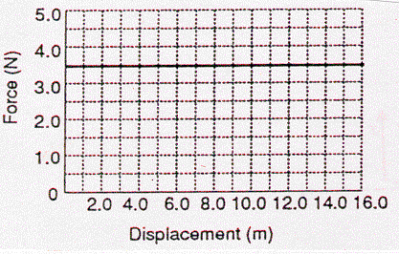 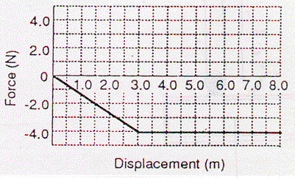

2. The cable of a large crane applies a force of 2.2 x 104 N to a demolition ball as the ball is lifted vertically a distance of 7.6 m. How much work does this force do on the ball? Is this work positive or negative? Explain. (+1.7 x 105 J)

3. Fred is moving into an apartment at the beginning of the school year. Fred weighs 685 N and his belongings weigh 915 N. How much work does the elevator do in lifting Fred and his belongings up five stories (15.2 m)? How much work does the elevator do on Fred on the downward trip? (+2.43 x 104 J, -1.04 x 104 J)

4. The drawing below shows a boat being pulled by two locomotives through a two kilometre canal. The tension in each cable is 5.00 x 103 N and  = 20o. What is the work done on the boat by the locomotives? (1.88 x 107 J)

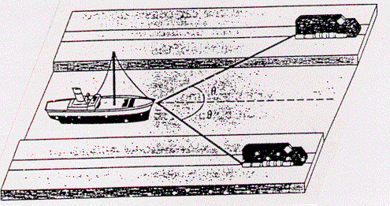

5. A 2.40 x 102 N force, acting at 20o above the surface, is pulling on an 85.8 kg refrigerator across a horizontal floor. The frictional force opposing the motion is 1.67 x 102 N and the refrigerator is moved a distance of 8.00 m. Find the work done by the applied force and the work done by the frictional force.

(1.80 kJ, 1.34 kJ)

6. A 100 kg crate is pulled across a horizontal floor by a force P that makes a 30o angle with the floor. If the frictional force is 196 N, what would be the magnitude of P so that the net work is zero? (226 N)

7. A window washer on a scaffold is hoisting the scaffold up the side of a skyscraper by pulling down on a rope. The combined mass of the window washer and the scaffold is 155 kg. If the scaffold is pulled up at a constant velocity through a distance of 120 m:

a. How much work was done? (1.82 x 105 J)

b. What force must the window washer supply? (507 N)

c. How many meters of rope are required, assuming that the pulleys touch at the top? (360 m)

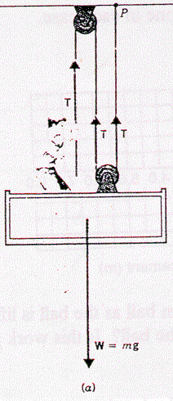 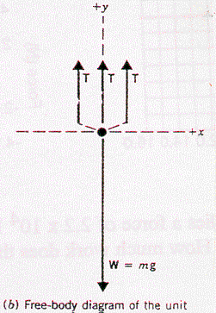

*Kinetic and Potential Energy Problems*

1. A 65.0 kg jogger is running at a speed of 5.30 m/s. What is the jogger’s kinetic energy? (913 J)

2. Relative to the ground, what is the energy of a 55.0 kg person at the top of the Sear's Tower in Chicago, which is 443 m high? (239 kJ)

3. A 75.0 kg skier rides a 2830 m long chair lift to the top of a mountain. The lift makes an angle of 14.6o with the horizontal. What is the change in the skier's potential energy? (525 kJ)

4. A spring is compressed 0.045 m by a 120 N force. What is the spring constant and how much energy is in the spring? (2.67 x 103 N/m, 2.7 J)

5. A spring with a spring constant of 25 N/m is compressed by 9.6 cm. How much energy is in the spring? (0.12 J)

*Power Problems*

1. What is the standard unit of power? Is the unit kWh (kilowatt hour) a unit of force, energy or power? Explain.

2. What is the power output of a machine which applies a force of 2.50 x 104 N for 12.0 s in pulling a block through 60.0 m? (125 kW)

3. A machine has an output power of 10.0 kW. How long would it take for the machine to raise a 5000 kg load through a height of 2.5 m? (12.3 s)

4. Water flows over a section of Niagara Falls at the rate of 1.2 x 106 kg/s and falls 50.0 m. How much power is generated by the falling water? (5.9 x 108 W)

5. A machine operates at a power consumption of 3.5 kW for ten minutes. In the process it produces 500 kJ of waste heat energy. How much net work was done? (1.6 MJ)